Objectives:

* Writing and reading files
* Try and catch statement
* Intro to GUI Interfaces

**There are 8 challenge exercises with 8 print screens, each worth 12.5%**

Please submit this document for grading when completed… Please work in groups.

**Project #1** (Writing and Reading files)

**Challenge Exercise #1:** write a program that will ask the user to enter the first, last name with the age, and write the contents to a file, and then read from the file.

**#1 Print screen the running application with the code below here.**

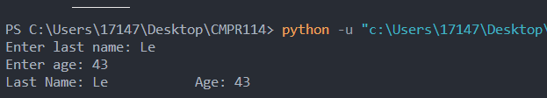

Code:

lastname = input("Enter last name: ")

age = input("Enter age: ")

file = open("C:\\Users\\17147\\Desktop\\CMPR114\\m3\\exercise1.txt", "w")

file.write(f"Last Name: {lastname} \t\tAge: {age}\n")

file.close()

with open("C:\\Users\\17147\\Desktop\\CMPR114\\m3\\exercise1.txt", "r") as file1:

filecontent = file1.read()

print(filecontent)

file1.close

**Project #2** (Writing numeric data)

**Challenge Exercise #2:** continuing with project #2, read the data using the print statement.

**#2 Print screen the running application with the code below here.**

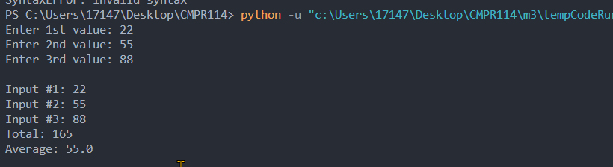

Code:

def write():

totalsum = 0

outfile = open("C:\\Users\\17147\\Desktop\\CMPR114\\m3\\exercise2.txt", "w")

num1 = int(input("Enter 1st value: "))

num2 = int(input("Enter 2nd value: "))

num3 = int(input("Enter 3rd value: "))

sum = num1 + num2 + num3

totalsum += sum

avg = totalsum/3

outfile.write(f"Input #1: {num1}\n")

outfile.write(f"Input #2: {num2}\n")

outfile.write(f"Input #3: {num3}\n")

outfile.write(f"Total: {totalsum}\n")

outfile.write(f"Average: {avg}\n")

outfile.close()

write()

file = open("C:\\Users\\17147\\Desktop\\CMPR114\\m3\\exercise2.txt", "r")

content = file.read()

print("")

print(content)

file.close

**Project #3** (Writing and reading the Sales Data)

**Challenge Exercise #3:** continuing from project #3, write a program that will ask the user to enter the sales with salary, and if the total sales are greater than 1000 add 10% commission to the salary write and read the data using the print statement.

*Please enter the following test data: enter 80,000 for the salary, enter the days of sale as 5, and each sale entered will be 1000, see below.*

**#3 Print screen the running application with the code below here.**

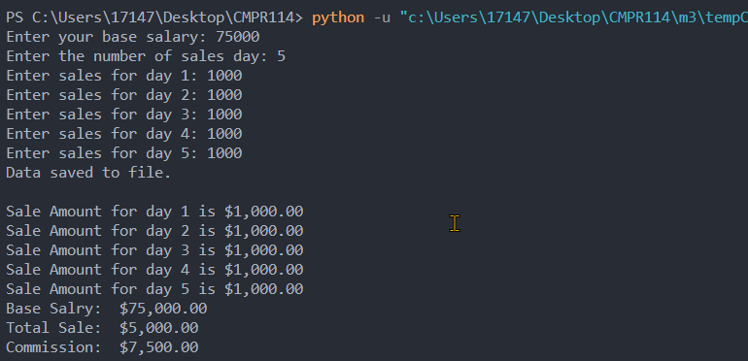

Code:

def sales():

salary = int(input("Enter your base salary: "))

num_days = int(input("Enter the number of sales day: "))

sales_file = open("C:\\Users\\17147\\Desktop\\CMPR114\\m3\\exercise3.txt", "w")

totalsale = 0

for item in range(1,num_days+1):

sale = float(input(f"Enter sales for day {item}: " ))

sales_file.write(f"Sale Amount for day {item} is ${sale:,.2f}\n")

totalsale += sale

if totalsale > 1000:

commission = salary * .1

else:

commission = 0

sales_file.write(f"Base Salry: ${salary:,.2f}\n")

sales_file.write(f"Total Sale: ${totalsale:,.2f}\n")

sales_file.write(f"Commission: ${commission:,.2f}\n")

sales_file.close

print("Data saved to file.")

sales()

#Read file and output to screen

sale_file = open("C:\\Users\\17147\\Desktop\\CMPR114\\m3\\exercise3.txt", "r")

content = sale_file.read()

print("")

print(content)

**Project #4** (Write Records)

**Challenge Exercise #4:** Continuing with project #4, read the content of the employees.txt file.

**#4 Print screen the running application with the code below here.**

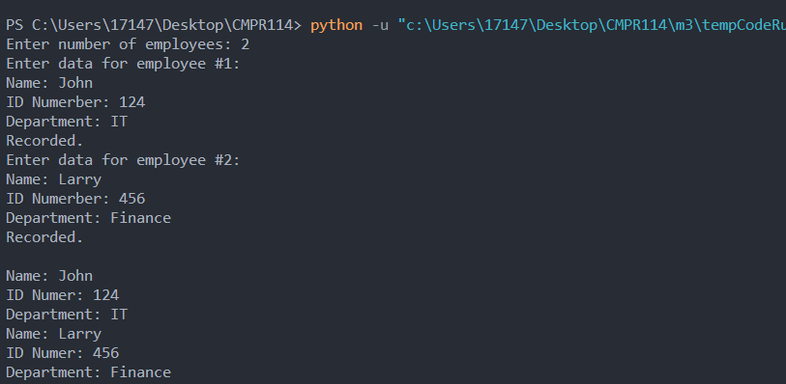

Code:

def main():

num_employee = int(input("Enter number of employees: "))

emp_file = open("C:\\Users\\17147\\Desktop\\CMPR114\\m3\\exercise4.txt", "w")

for count in range(1, num_employee+1):

print(f"Enter data for employee #{count}: ")

name = input("Name: ")

idnum = input("ID Numerber: ")

dept = input("Department: ")

emp_file.write(f"Name: {name}\n")

emp_file.write(f"ID Numer: {idnum}\n")

emp_file.write(f"Department: {dept}\n")

emp_file.close

print("Recorded.")

main()

file = open("C:\\Users\\17147\\Desktop\\CMPR114\\m3\\exercise4.txt", "r")

content = file.read()

print()

print(content)

**Project #5:** Using the try-and-catch statement with the while loop.

**Project #5 (**Introducing GUI interfaces using Tkinter)

**Challenge Exercise #5:** Continuing with project #5, add the address, city, and state with the zip code and transfer the information to a text file.

**#5 Print screen the running application with the code below here.**

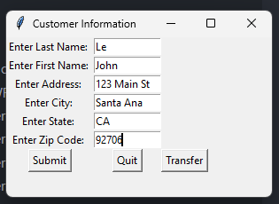

Code:

import tkinter as tk

from tkinter import messagebox

win = tk.Tk() #Create window interface

win.geometry("300x180") #Set window size

win.title("Customer Information") #Label title for window

lbllastname = tk.Label(win, text = "Enter Last Name: ").grid(column=0, row=0) #Label widge

lblfirstname = tk.Label(win, text = "Enter First Name: ").grid(column=0, row=1) #Label widge

lbladdress = tk.Label(win, text = "Enter Address: ").grid(column=0, row=2) #Label widge

lblcity = tk.Label(win, text = "Enter City: ").grid(column=0, row=3) #Label widge

lblstate = tk.Label(win, text = "Enter State: ").grid(column=0, row=4) #Label widge

lblzipcode = tk.Label(win, text = "Enter Zip Code: ").grid(column=0, row=5) #Label widge

def write():

file = open("C:\\Users\\17147\\Desktop\\CMPR114\\m3\\exercise5.txt", "w")

content = file.write("\nConfirmation: " + LN.get() + "," + FN.get() + "\n" +

ADDR.get() + "\n" + CITY.get() + ", " + STATE.get() + " " + ZIP.get() )

file.close

messagebox.showinfo("Information", "Data Recorded.")

def quit():

messagebox.showinfo("Information", "Thank You.")

win.destroy()

def submit():

messagebox.showinfo("Information", "You've entered: \n" + LN.get() + "," + FN.get() + "\n" +

ADDR.get() + "\n" + CITY.get() + ", " + STATE.get() + " " + ZIP.get() ) #Display Info

LN = tk.StringVar() #Manage the Entry widget

txtlastname = tk.Entry(win, width=12, textvariable=LN).grid(column=1,row=0)

FN = tk.StringVar() #Manage the Entry widget

txtfirstname = tk.Entry(win, width=12, textvariable=FN).grid(column=1,row=1)

ADDR = tk.StringVar() #Manage the Entry widget

txtaddress = tk.Entry(win, width=12, textvariable=ADDR).grid(column=1,row=2)

CITY = tk.StringVar() #Manage the Entry widget

txtcity = tk.Entry(win, width=12, textvariable=CITY).grid(column=1,row=3)

STATE = tk.StringVar() #Manage the Entry widget

txtstate = tk.Entry(win, width=12, textvariable=STATE).grid(column=1,row=4)

ZIP = tk.StringVar() #Manage the Entry widget

txtzipcode = tk.Entry(win, width=12, textvariable=ZIP).grid(column=1,row=5)

btnSubmit = tk.Button(win, text="Submit", command = submit).grid(column=0, row=7)

btnQuit = tk.Button(win, text="Quit", command = quit).grid(column=1, row=7)

btnWrite = tk.Button(win, text="Transfer", command = write).grid(column=2, row=7)

win.mainloop()

**Challenge Exercise #6:** Create a **GUI** interface that will write 3 numbers and sum + average the total into a text file.

**Example output in the text file**

The three numbers are: 1, 2 and 3

The total is 6

The average is 2

**#6 Print screen the running application with the code below here.**

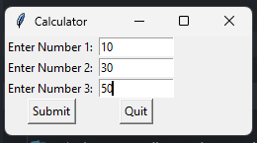

Code:

import tkinter as tk

from tkinter import messagebox

win = tk.Tk() #Create window interface

win.geometry("250x100") #Set window size

win.title("Calculator") #Label title for window

lblnum1 = tk.Label(win, text = "Enter Number 1: ").grid(column=0, row=0) #Label widge

lblnum2 = tk.Label(win, text = "Enter Number 2: ").grid(column=0, row=1) #Label widge

lblnum3 = tk.Label(win, text = "Enter Number 3: ").grid(column=0, row=2) #Label widge

def quit():

messagebox.showinfo("Information", "Bye.")

win.destroy()

def submit():

val1 = NUM1.get()

val2 = NUM2.get()

val3 = NUM3.get()

total = int(val1) + int(val2) + int(val3)

avg = total/3

file = open("C:\\Users\\17147\\Desktop\\CMPR114\\m3\\exercise6.txt", "w")

content = file.write(f"\nThe three numbers are: {val1}, {val2}, {val3}" )

content = file.write(f"\nThe total is: {total}")

content = file.write(f"\nThe average is: {avg}")

file.close

messagebox.showinfo("Information", "You've entered: " + NUM1.get() + "," + NUM2.get() + "," + NUM3.get())

NUM1 = tk.StringVar() #Manage the Entry widget

txtnum1 = tk.Entry(win, width=12, textvariable=NUM1).grid(column=1,row=0)

NUM2 = tk.StringVar() #Manage the Entry widget

txtnum2 = tk.Entry(win, width=12, textvariable=NUM2).grid(column=1,row=1)

NUM3 = tk.StringVar() #Manage the Entry widget

txtnum3 = tk.Entry(win, width=12, textvariable=NUM3).grid(column=1,row=2)

btnSubmit = tk.Button(win, text="Submit", command = submit).grid(column=0, row=3)

btnQuit = tk.Button(win, text="Quit", command = quit).grid(column=1, row=3)

win.mainloop()

**Challenge Exercise #7:** Create a console (**NO GUI**) application that will ask the user to enter the full name, with the grade of the midterm and final exam, and **write** the **average** grade with **letter** grade into a text file. Use the table as a guide. Use also the try statement for this application. Make sure to append the data and **read** the content of the file also.

Use the

|  |  |
| --- | --- |
| 90-100 | Letter grade A |
| 80-89 | Letter grade B |
| 70-79 | Letter grade C |
| 60-69 | Letter grade D |
| Under 60 | Letter grade F |

**#7 Print screen the running application with the code below here.**

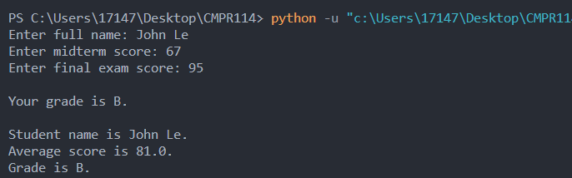

Code:

def calc_grade(name, score1, score2):

total = score1 + score2

avg = total/2

if avg >= 90:

grade = "A"

elif avg >= 80:

grade = "B"

elif avg >= 70:

grade = "C"

elif avg >= 60:

grade = "D"

else:

grade = "F"

file = open("C:\\Users\\17147\\Desktop\\CMPR114\\m3\\exercise7.txt", "a")

file.write(f"\nStudent name is {name}.")

file.write(f"\nAverage score is {avg}.")

file.write(f"\nGrade is {grade}.\n")

file.close

return grade

try:

name = input("Enter full name: ")

score1 = int(input("Enter midterm score: "))

score2 = int(input("Enter final exam score: "))

lettergrade = calc_grade(name,score1, score2)

print(f"\nYour grade is {lettergrade}.")

file = open("C:\\Users\\17147\\Desktop\\CMPR114\\m3\\exercise7.txt", "r")

content = file.read()

print(content)

file.close

except ValueError:

print("Error: input error")

except Exception as err:

print(err)

**Challenge Exercise #8:** create a console application (**NO GUI**) that will write random numbers from 1-10 into a text file and read the contents.

**#8 Print screen the running application with the code below here.**

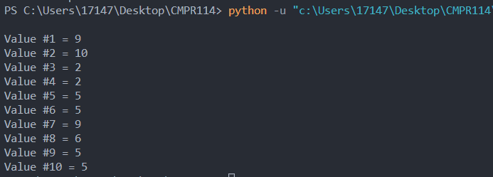

Code:

import random

def write():

file = open("C:\\Users\\17147\\Desktop\\CMPR114\\m3\\exercise8.txt", "w")

for i in range(1,11):

val = random.randint(1,10)

file.write(f"\nValue #{i} = {val}")

file.close

write()

file = open("C:\\Users\\17147\\Desktop\\CMPR114\\m3\\exercise8.txt", "r")

content = file.read()

print(content)

file.close

**Submit this document to the Module 3 Class Exercise.**